**Switch A Server**

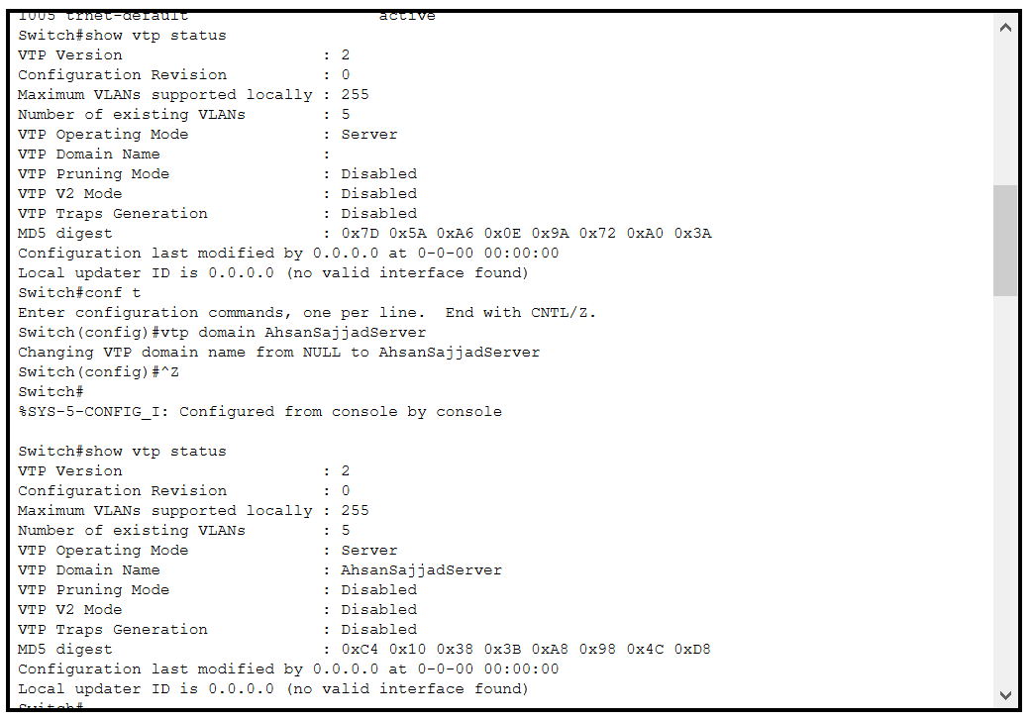

**Server sa ja 2 client ko connection ja rraha han unhan trunk karna ha**

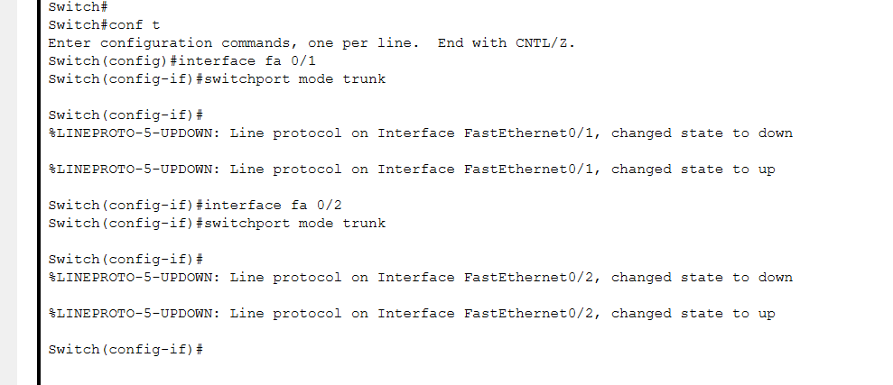

**Vlan create Student aur faculty ka aur jis client switch pa vlan banayan ga same iid ka sirf wahin packet transfer ho ga**

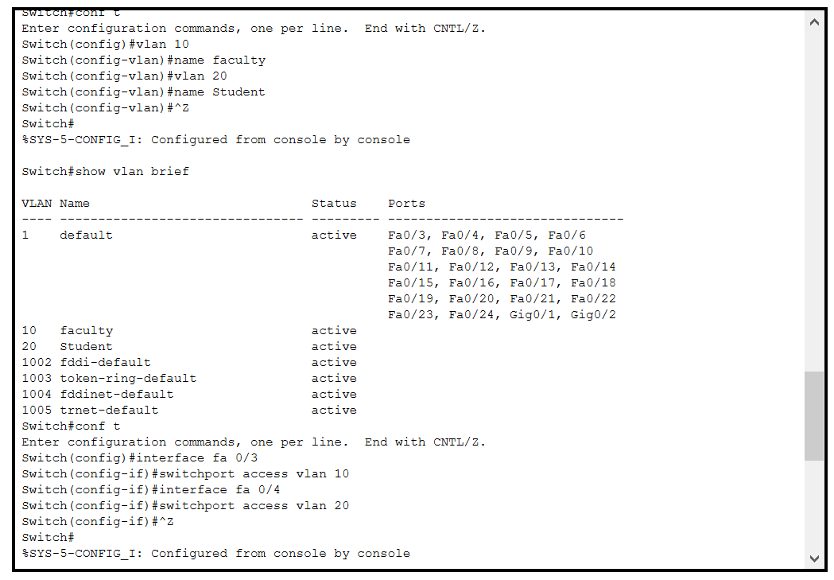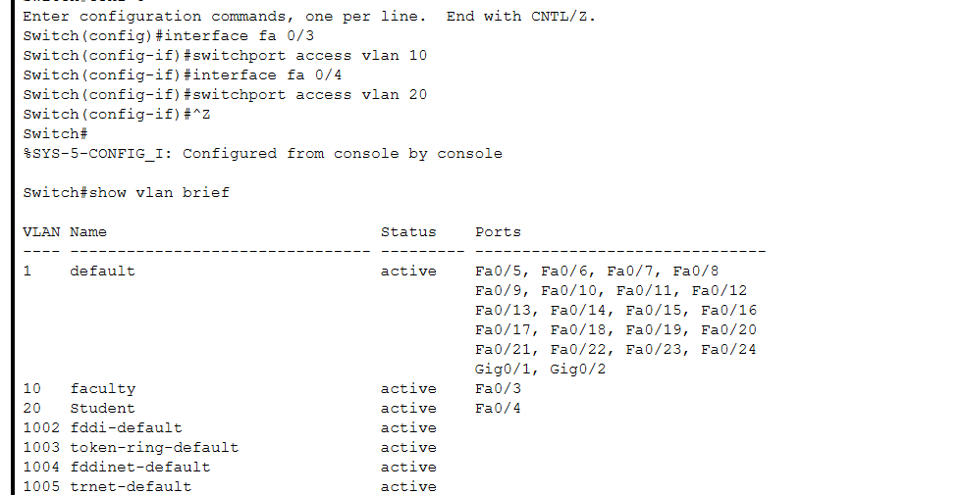

**SWITCH B Client**

**Mode set to client**

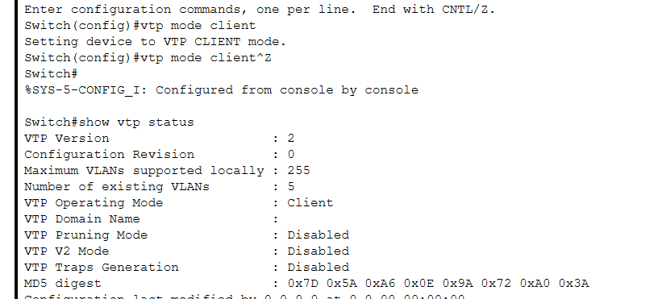

**Trunk the connection jo server sa aaraha ha**

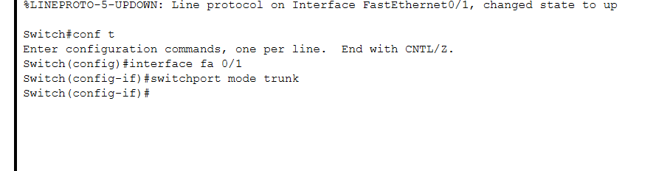

**Connection to server Done**

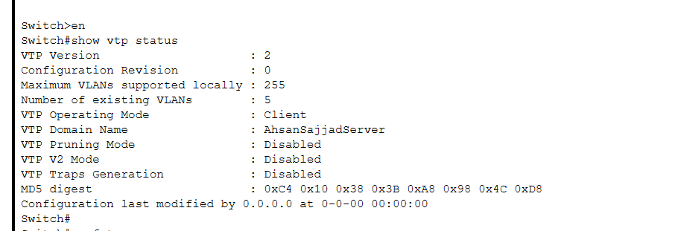

**Pcs of client B connected to vlan of server so the can sent packets to each other**

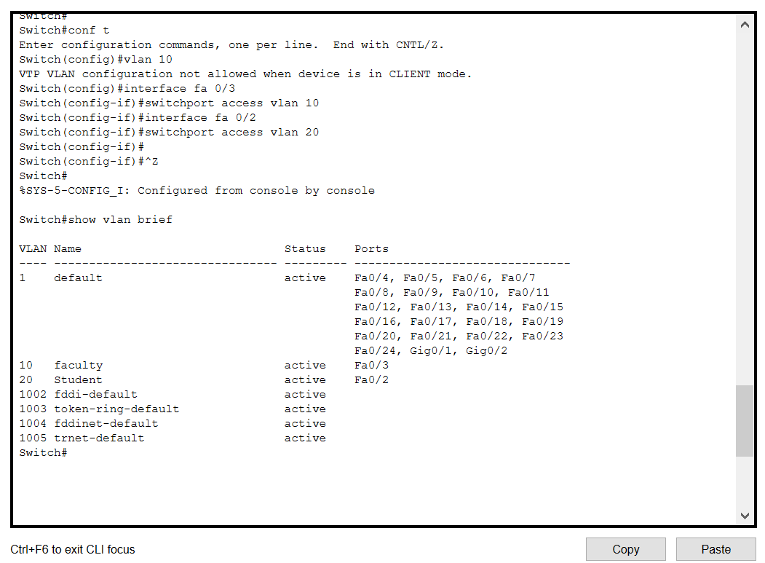

**SWITCH C**

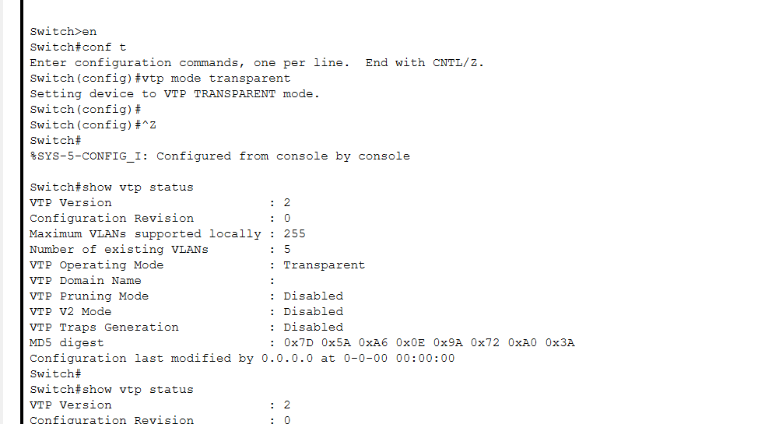

**SWITCH D**

**Set client mode**

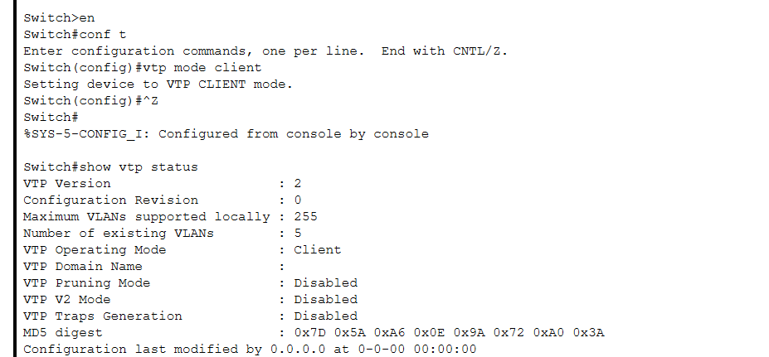

**Trunk to connection jo server sa aarha ha**

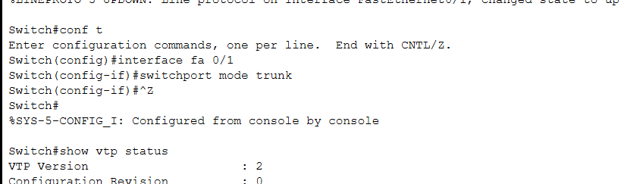

**Connection to server done**

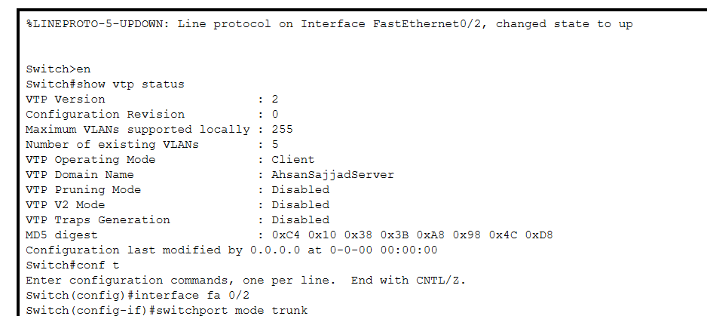

**Is client ko server ka vlan sa connect nai kran ga aur iska pcs ko packet b send nai hon ga**